***Free Associations: Psychoanalysis and Culture, Media, Groups, Politics***

**Number 76 September 2019 ISSN: 2047-0622**

**URL:** [**http://www.freeassociations.org.uk/**](http://www.freeassociations.org.uk/)



**The Uncanny Art of Rita Nowak: The Photographs of the Viennese Artist Rita Nowak (2019) and Sigmund Freud's *Das Unheimliche*, "The Uncanny" {1919)**

Patricia Morris

Patrician Morris

The impact of an art work happens below – or should one say above – the level of language. T­­o interpret an art work is, like the process of psychoanalysis, an attempt to bring to consciousness what was previously unconscious.

What is made conscious is not always expressible in language. Some way into the process, for instance, a psychotherapy patient can observe that she feels a change within, usually associated with an unprecedented question about herself, or an insight about something familiar that makes it new, as if an unseen gear has clicked into place. Often there are no words adequate to describe this interior shift. It can be a feeling that grows imperceptibly until it can be remarked upon, or it can present itself in a striking moment like a musical note that sounds in the silence, or a tear that suddenly appears on the back of your hand. It is a felt quality rather than a quantity that can be measured, the reason that workers in the psychoanalytic field are so resistant to the measurement of their effect. It is also the reason that art and psychoanalytic practices are never far apart.

Rita Nowak’s photographs offer visual echoes of the parts of an experience that become greater than the whole. At first glance what she puts in front of us is a pretty tableau, something that reminds us of, say, an early Romantic landscape painting, or an Arthur Rackham illustration for a children’s book. When we look again, we find nothing of the sort. A certain strangeness filters through and then engulfs the perceived perfection of each image so that there is no going back to our first impression of it. The lovely components combine into something puzzling or strangely unsettling. The surface is familiarly idealised but we are not looking at a depiction of reality that coincides with our own world. Something peculiar has been caught on camera, something that obeys its own exotic laws of spatial – and emotional – causality. There is an emanation that has the quality of a disturbing, confusing dream, what Sigmund Freud called “the uncanny”, “*das unheimliche”*. Rita Nowak’s serene surfaces draw us in, and when we are in, we are in a state that teeters on the edge of nightmare. (**RN: *Sveta***)

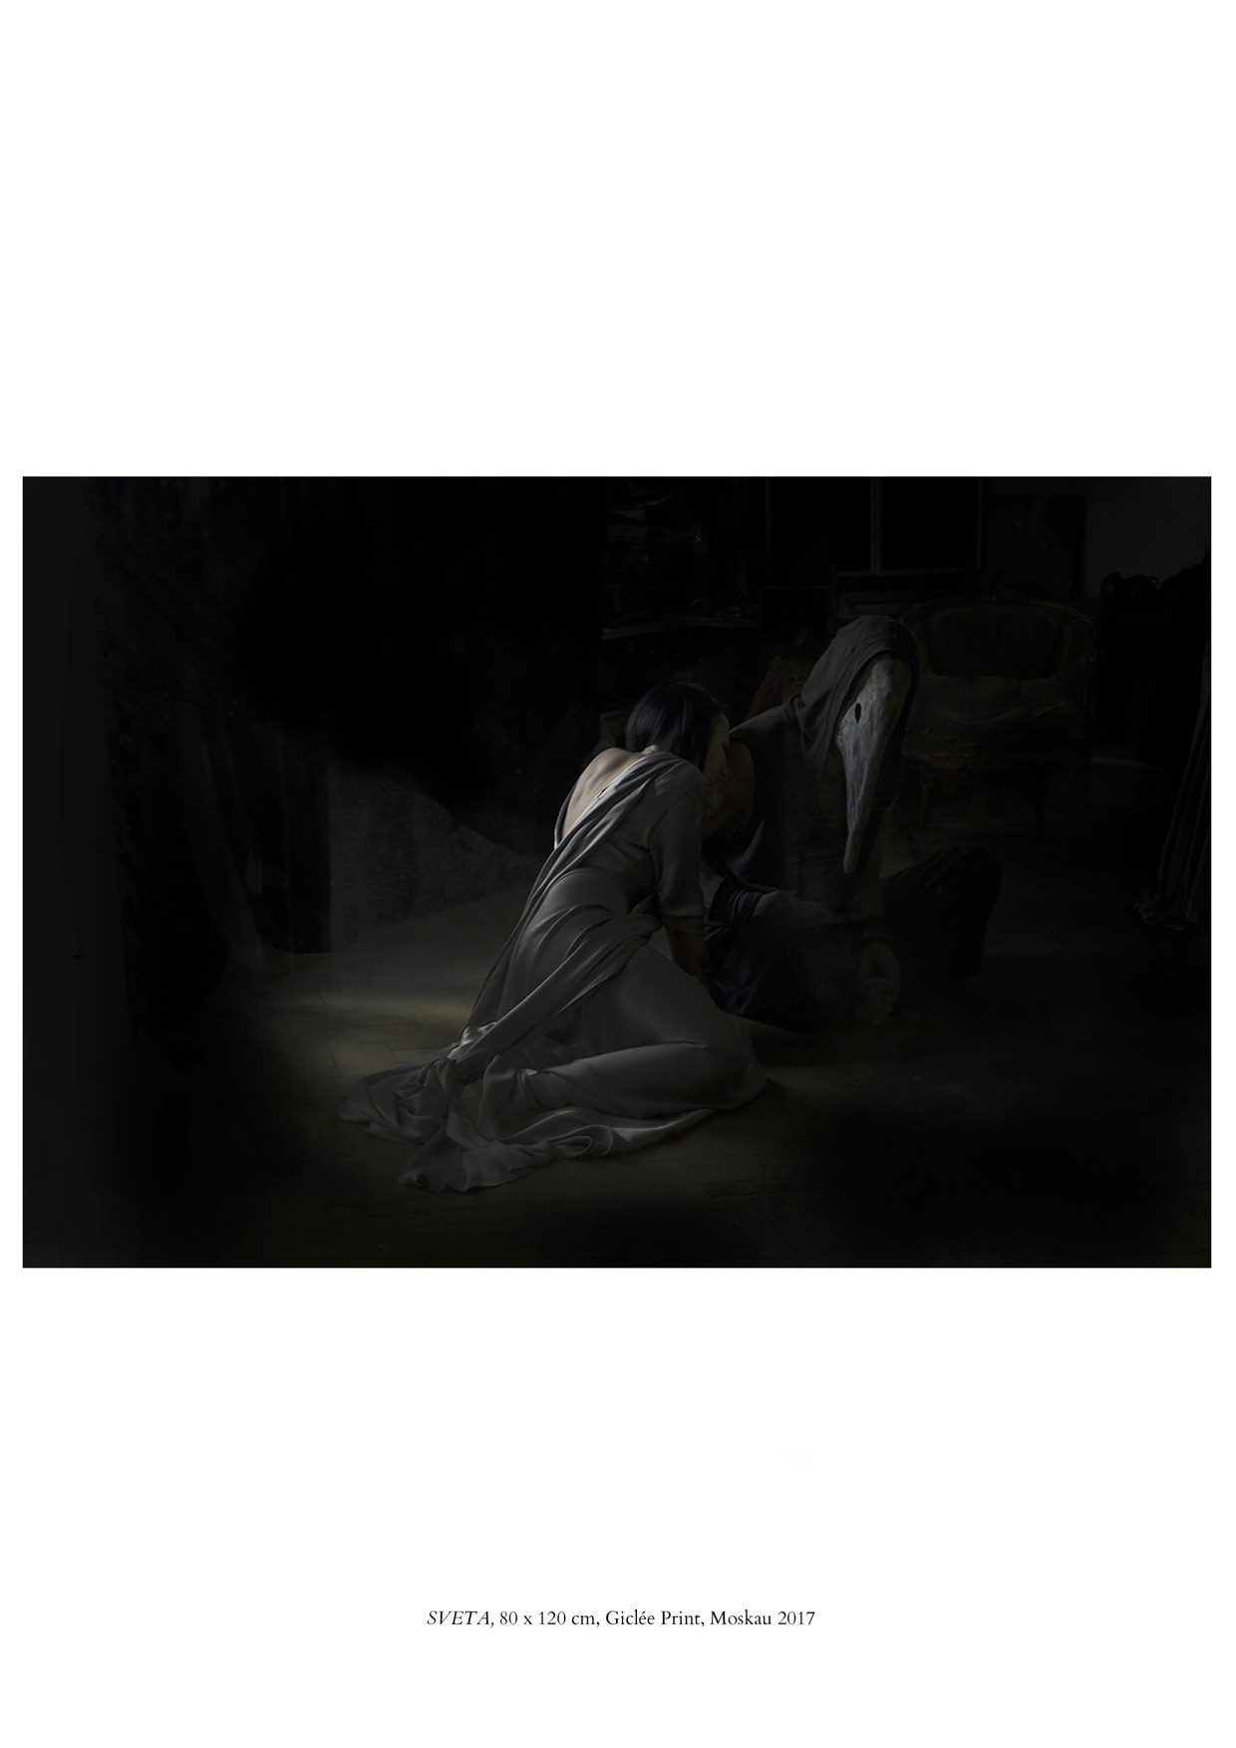

In her theatrical stagings in melodramatic settings, the precisely directed characters wear facial expressions, if they are even visible, that are self-absorbed, possibly grave, always ambiguous. Because everything seems beautiful, we almost suppose that we may be safe. We do not turn away from the picture, screaming. This is not horror. But it could become that. Or could it? Often there is humour. We are left with what Freud calls “intellectual uncertainty”, characteristically associated with the experience of the uncanny. What is bearable, sometimes desirable, Nowak has translated into the unease, even fear, elicited by the ordinary, half-familiar figures and almost natural landscapes encountered in nightmares.

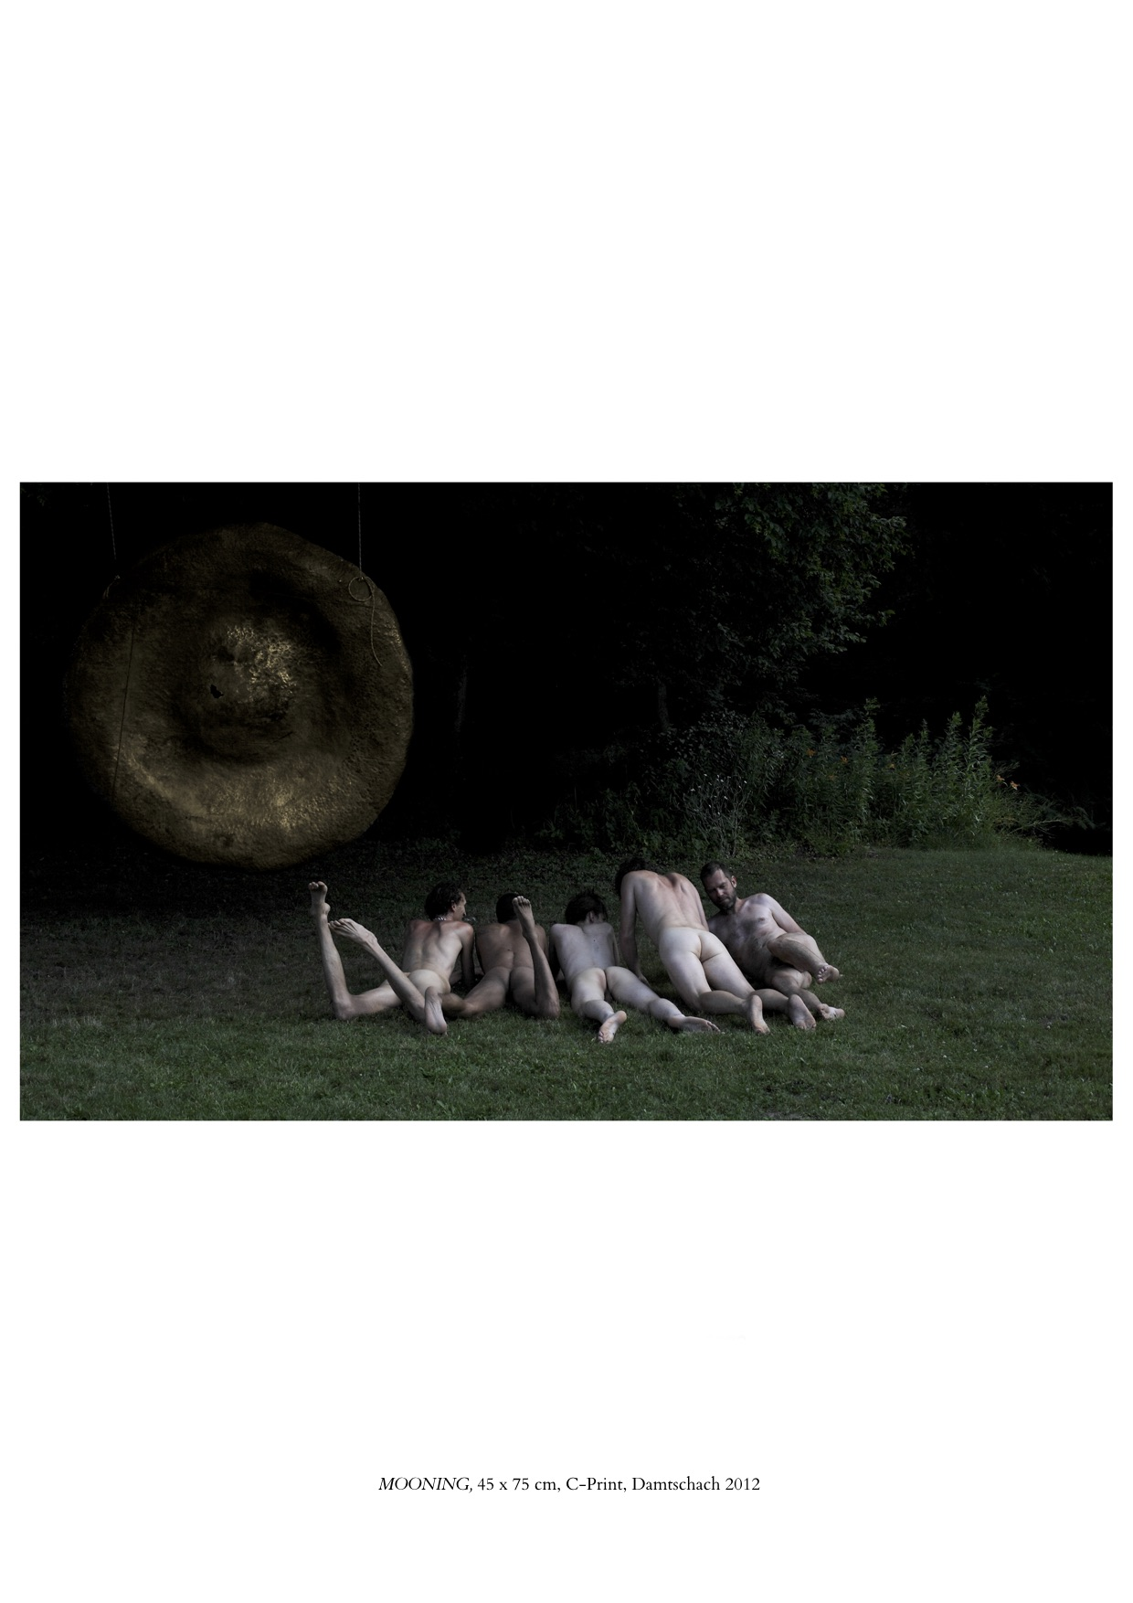

In the woods we appear to have stumbled upon a row of prone but amusingly lively buttocks ranged like keys on a piano waiting to be played. As elsewhere in her work, the darkest, velvety background throws into relief the models’ opalescent skin gleaming under ethereal lighting. (**RN: *Mooning***)

Beyond, there looms into view a mysterious golden asteroid, or sun, or moon. It could be a monument to a multi-functional orifice, or perhaps to the shy tip of a protuberance, or a mouthy bloom with a swollen pistil. Or, who knows, it is a big blind eye left behind by a cyclops. In any event, it may be a wise move to prostrate oneself before it. The grand object, which represents something that we do not understand, puts one in mind of Freud’s observation that an uncanny effect is produced “when something that we have hitherto regarded as imaginary appears before us in reality, or when a symbol takes over the full functions of the thing it symbolizes”. It may force upon us “the idea of something fateful and inescapable”. So now we are left worryingly uncertain about the influence of this dominant object upon the playful activities in the foreground. It turns out that the bottoms belong not to romping children in a fairy glade but to a group of merry, hairy, grown, prone men. Their line-up hints at a divertissement, an overture to, who knows, a game of frottage. The atmosphere is boisterous, amused and amusing, yet a strangeness arises partly from the gaze of that great gilt eye, and partly from uncertainty as to whether oneself, the viewer, is another kind of eye, an accidental witness to the event, or a spy, or a participant.

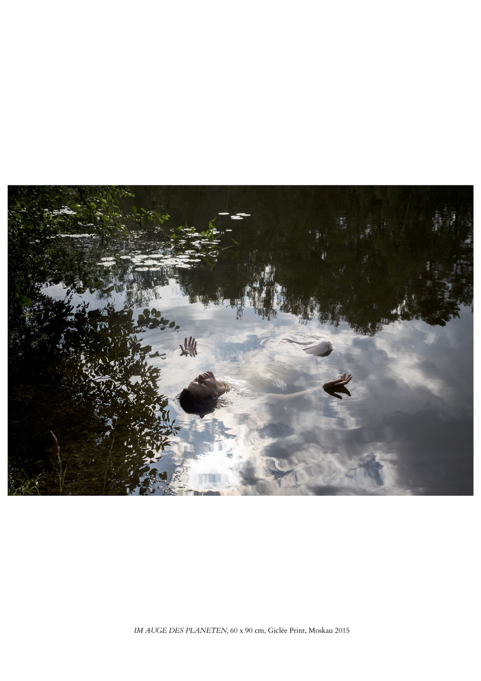

We come to a languid image whose title is ***Im Auge des Planeten***. It translates as *In the Eye of the Planet* but reminds us too of the figure of Auge in Greek myth. A creamy Ophelia is afloat in an almost monochrome, Monet-esque lily-pond reflecting a puff-ball bright sky. (**RN: *Im Auge des Planeten***)

“Her clothes spread wide,/ and mermaid-like, a while they bore her up”, as Shakespeare put it in *Hamlet*. We fear that this woman, tangled in her clinging robes, may be about to drown. “But long it could not be,/ Till that her garments, heavy with her drinke,/ Pulled the poor wretch . . . / To muddy death.” We don’t quite know what to make of the upside down, hard-to-read expression on the face of the model (actually the Moscow art curator Anya Dorofeeva). In the photograph’s exquisite totality, has the woman surrendered to Morpheus? Or to Thanatos? No, neither. Forget the cotton-candy clouds. More likely, we are Peeping Toms spying on the private bliss of Auge, the virgin priestess, just ravished by Hercules. She may be half drowning, or she may be recently raised from the blackest depths, but given that Hercules is the most über-macho of macho heroes and the entirety of the image’s mood is post-coital, we may only conclude that what we witness is Auge borne up on a lake of semen.

Nowak, refusing to lead us along a straightforward emotional path, seduces us, leads us astray, leaves us to stray.

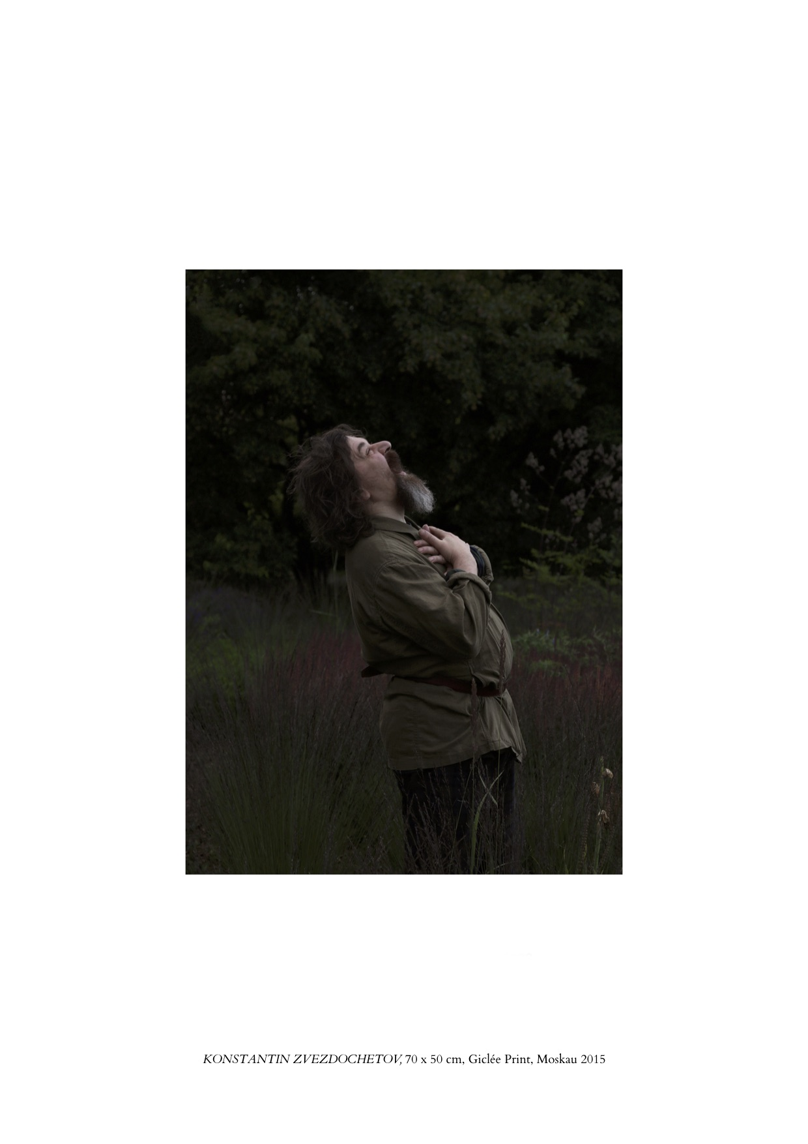

Something similar may be said of the effect of the full-length portrait of the bearded man (actually the artist Konstantin Zvezdochetov) disguised as Tolstoy. Is he singing joyfully unto the heavens or is he howling at the moon with grief? Or rage? **(RN: *Konstantin* *Zvezdochetov*)**

We waiver between the discrepant affective responses evoked in us. We doubt not the artist, but ourselves.

Elsewhere bodies may have a logical structure all their own. There are many-limbed, heedless, headless sprites making a witty mound of artful entwinings. What have we here? Is this the two-backed beast in a day-glo tutu? Or is it three? (**RN: *Peonies II*; *Blume***) These playful bundles of conjoined, many-legged revellers – are they, is it, safe? Are we?

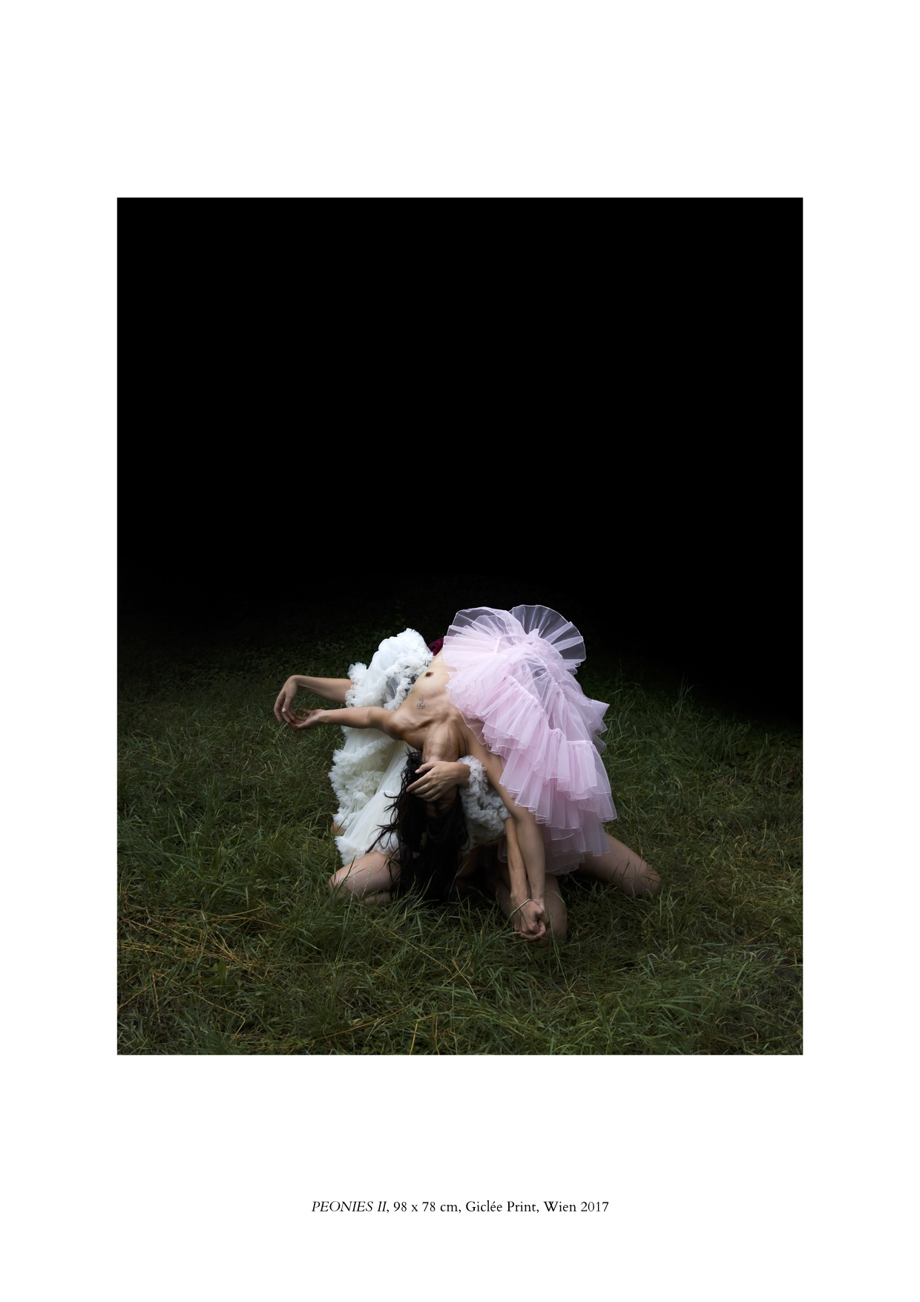

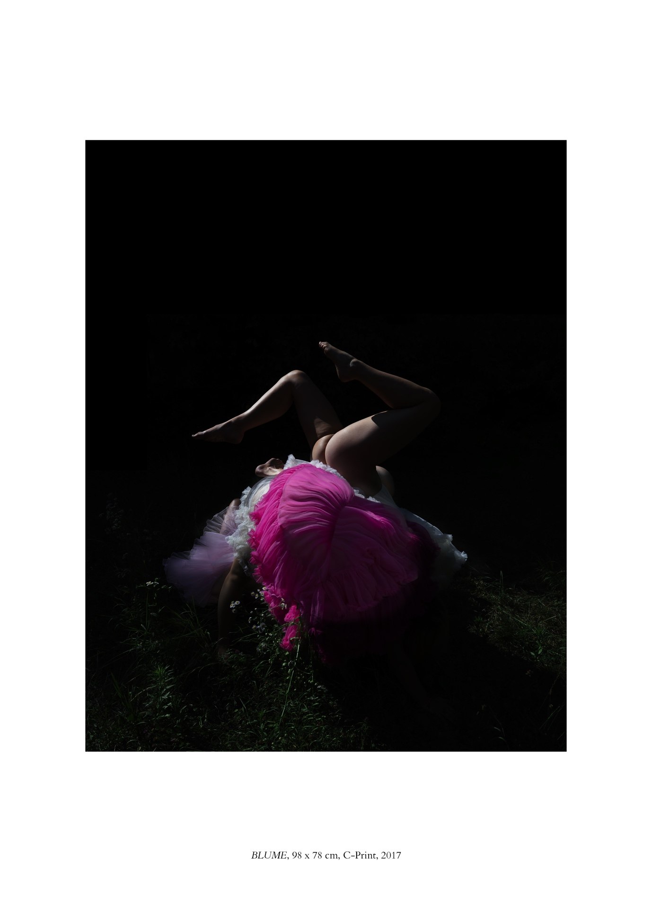

Often in the photographs, there are suggestive little openings into the erotic, the delightful, but beyond, there is darkness. Behind the image, or against it, is a place of blindness to go on to, that may, or may not, take us, or drop us, into something destructive. (**RN: *Aurelien*; *Nothing Disappears II***)

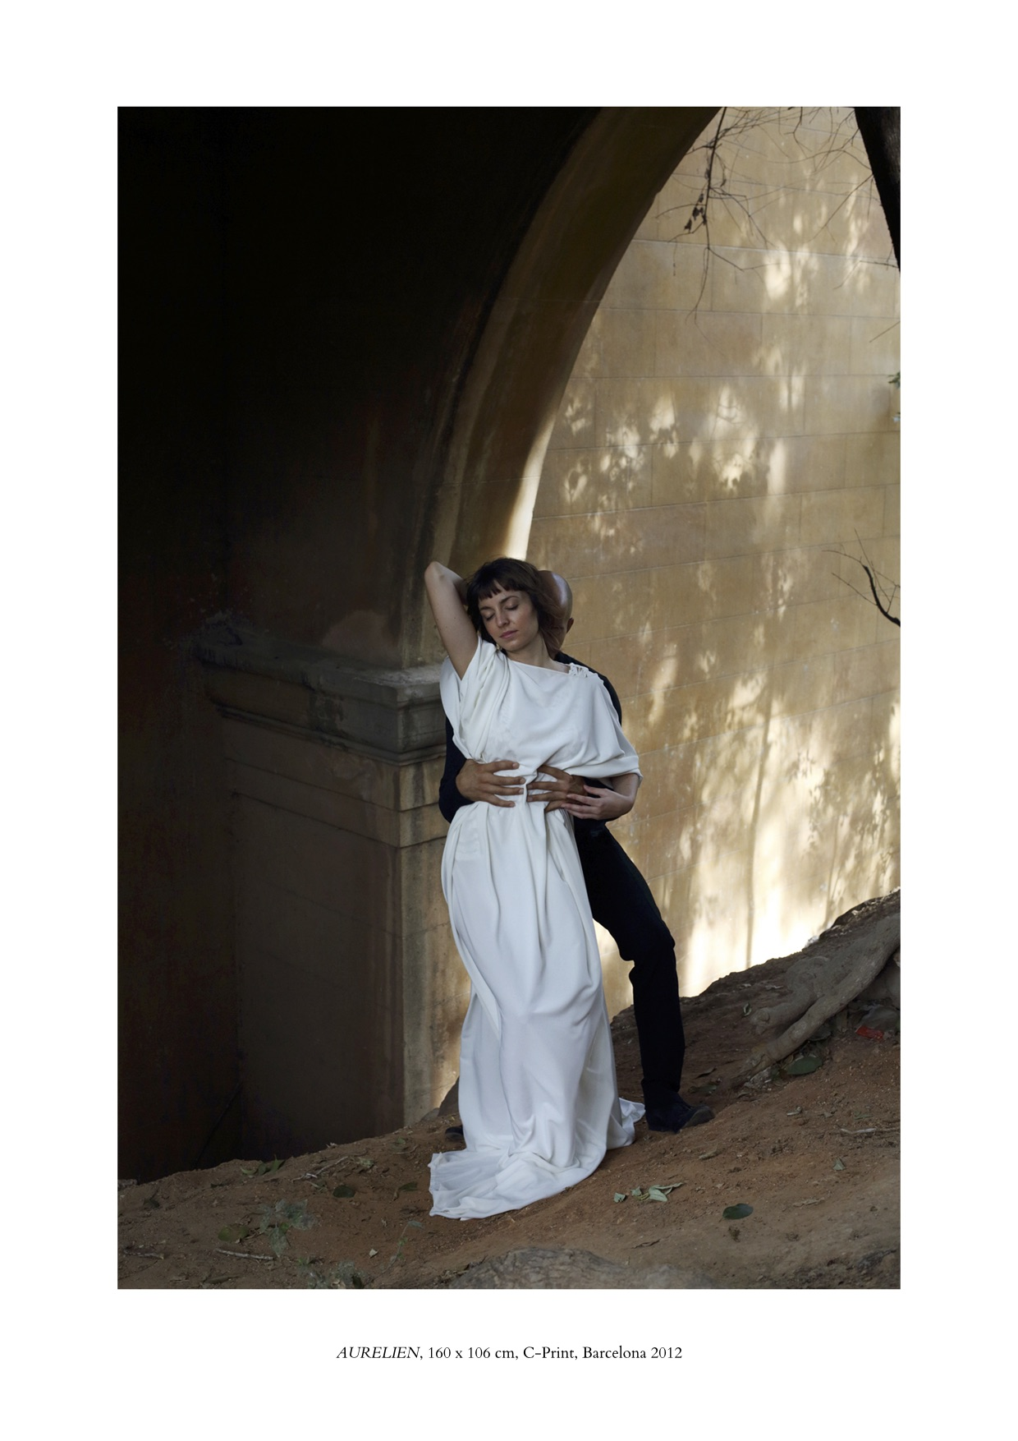

Amongst Nowak’s virtual quotations is the eroticised Edwardian sylvan scene – say, the Cottingley Fairies *sans* knickers (**RN: *Peonies II*; *Blume***; ***Mooning***); or an androgynous Renaissance page boy, or is that a Vermeer camera obscura backstage at the Folies Bergère? (**RN: *Rike***)

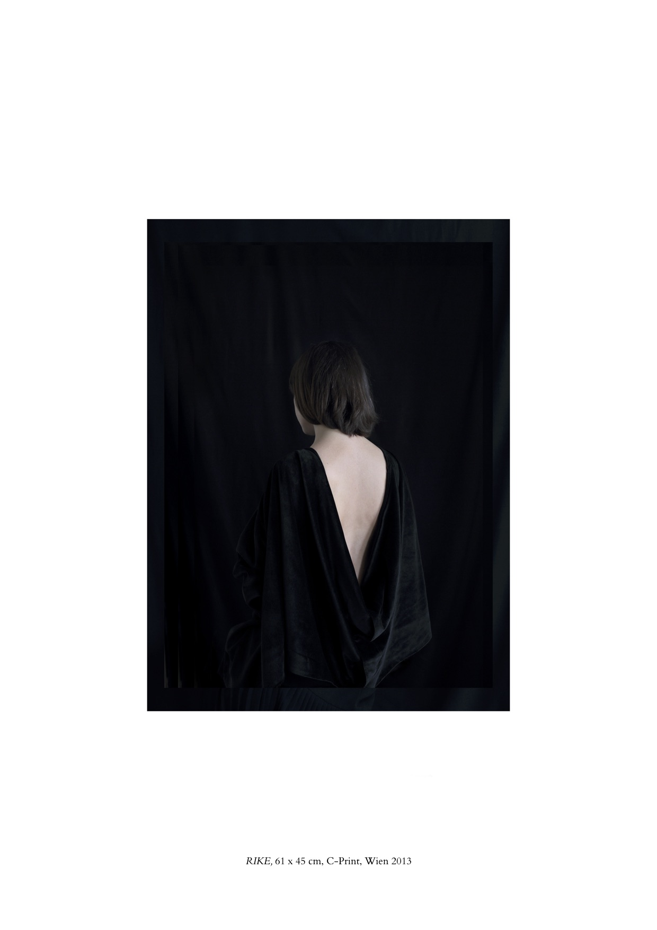

Nowak offers us ocular anachronisms that upend the sharp-edged visual categories that we bring along with us. That pudgy cherub being hauled aloft, is it a Rubensian babe with a Titian Virgin, each loving the cosy comfort of the other? (**RN: *Onil***) Or is that the Rokeby Venus resentfully roused from her sensuous repose to shift her piddling infant out of the way? But then look again. Is she a he?

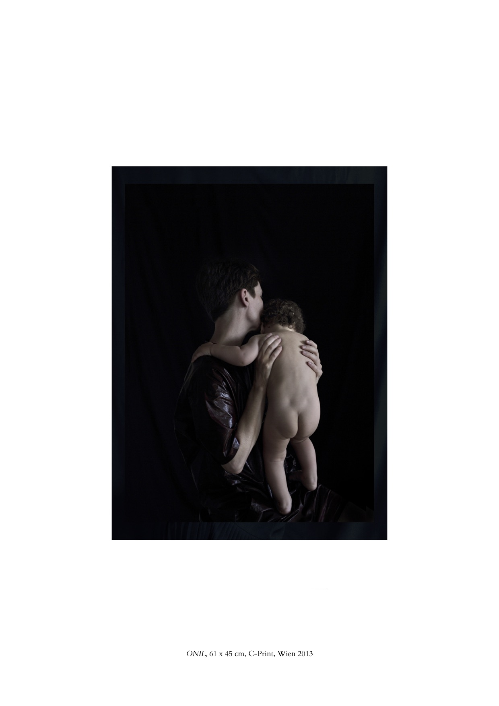

Nowak’s creatures wear, or hardly wear, yards of watery silk from the wardrobe of one of John Singer Sargent’s aristocrats, swathes of satin stolen from a Burne-Jones princess, flounces from the dressing room of Lautrec’s circus equestriennes. The props and furbelows may be extravagant studio investments or they may be mouldy old curtains, plastic sheeting, and polyester petticoats. It matters not, since mists materialise from the forest floor like gothic ghosts and we already have been lured helplessly deep into the enchanted thickets. (**RN: *Ardanaiseig***)

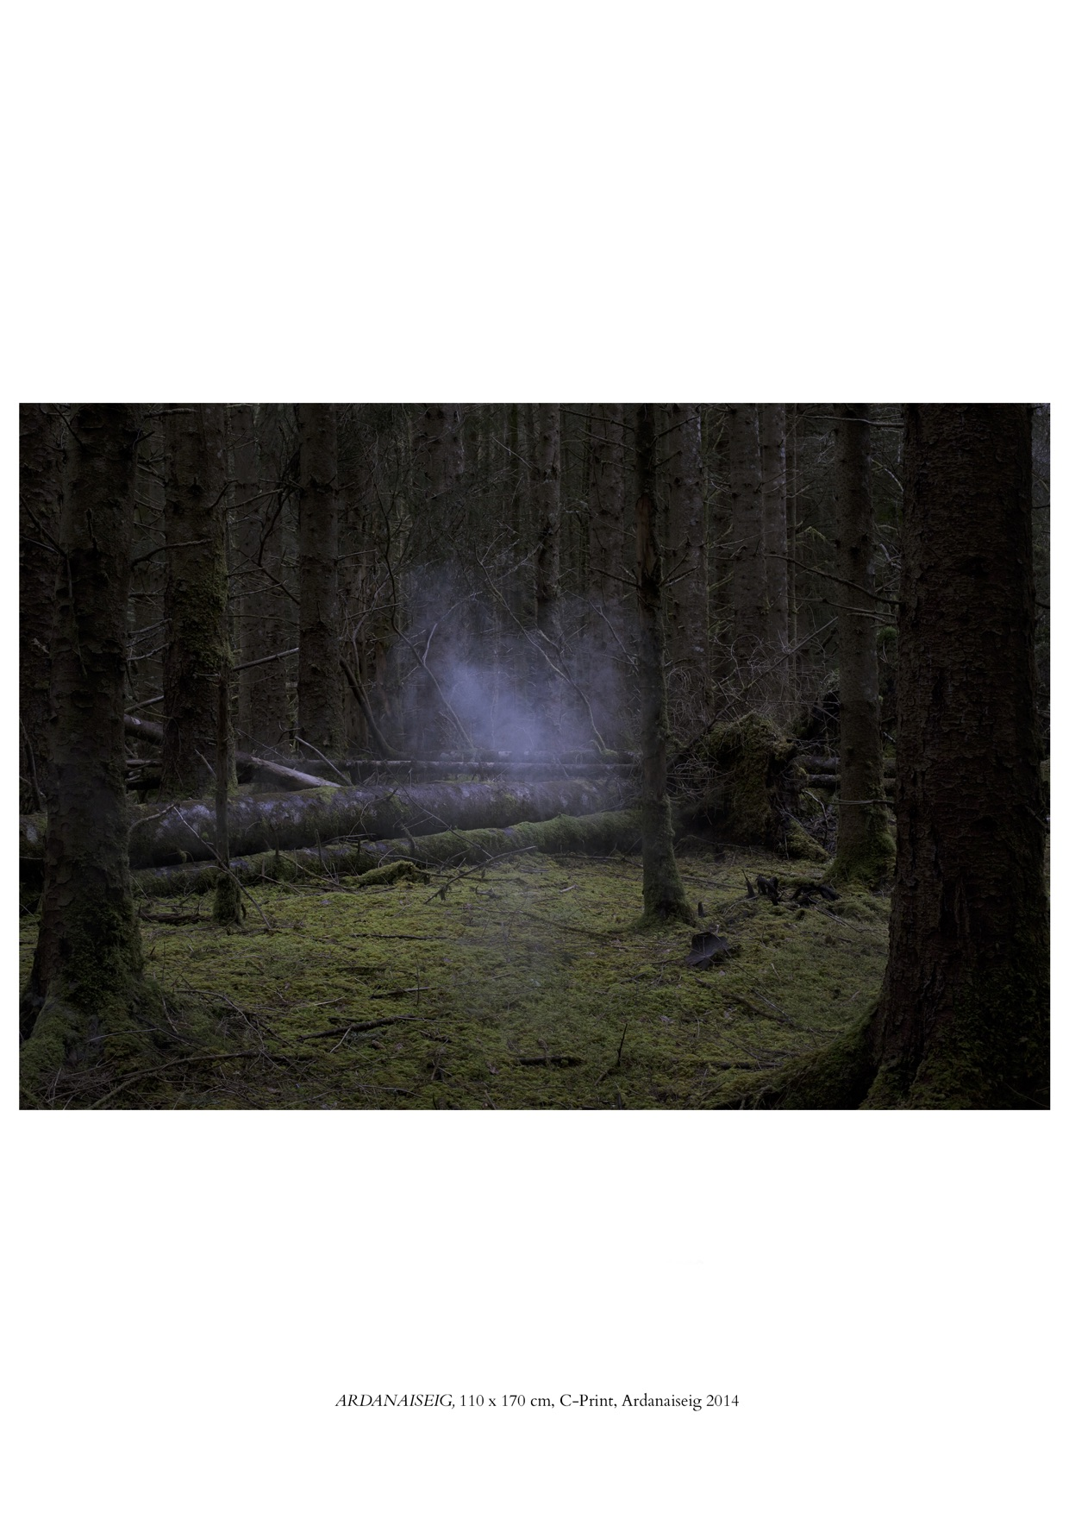

***

Exactly a century ago, in May 1919, Sigmund Freud, the founder of psychoanalysis, drafted the paper that we know as *Das Unheimliche*, attempting to describe the nature of the uncanny. The essay is, unusually for Freud, an astonishing mess and it is not surprising that few people seem actually to try to work through it. It is rambling, repetitive, oblique, difficult, combining pages of his painstaking research notes about what others have written on the topic before him, accidental clues for the reader as to how he worked out his own ideas, and inadvertent evidence of his cautious movement towards his major theory of the mechanisms of the id, ego and super-ego. But ostensibly he is on another track altogether. In his opening sentence, he acknowledges that he is venturing into an alien sphere, the subject of aesthetics, “understood to mean not merely the theory of beauty but the theory of the qualities of feeling.”

He has the impression that as a rule, until then, aesthetic studies largely have focused on “feelings of a positive nature”, not “feelings of repulsion and distress” as are circumscribed by the difficult term “*unheimlich*” which lies “within the field of what is frightening”. He admits that his researches have been limited by “the times in which we live”, namely World War I.

Freud returns several times in the course of his essay to the problem of defining in words the feeling of the uncanny because of its contradictory components – of the kind Nowak excels in evoking. He devotes several pages to examining the meaning of German speakers’ use of the words “*heimlich*” and “*unheimlich*” as both antonyms or synonyms. In German, *heimlich* can mean agreeable, cosy – and secret. It can also mean sinful, malicious – and secret. Which is it? The uncanny entails “intellectual uncertainty”. It is “something one does not know one’s way about in.” It “recalls the sense of helplessness experienced in some dream-states.” (**RN: *Nothing Disappears II***)

Freud identifies it as arising from the return to consciousness of “something which is familiar and old-established in the mind and which has become alienated from it only through the process of repression”. The uncanny is frightening because it can lead us back to what was once familiar, a direction in which our psyche does not want to go.

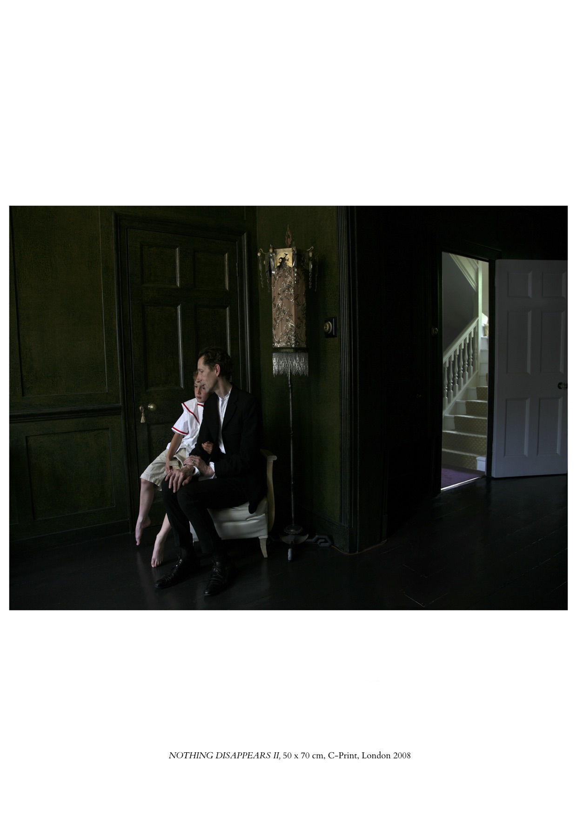

If analysts struggle to get to grips with what prompts feelings of the uncanny, it is probably because, as Freud discovers for us, it arises from two different kinds of repression, separated but overlapping, distinguished from one another by the nature of the material that the psyche is trying not to know.

On the one hand there is the “repression” of early emotional impulses, a process at the heart of Freud’s theory of the unconscious. Repressed emotional impulses are transformed into anxiety. When we witness something, or an event occurs that momentarily reintroduces to us what we have hitherto repressed, we may experience a feeling of the uncanny.

On the other hand, there is the process of “surmounting”, a variation on “repression”. Here what has to be hidden from consciousness are not emotional impulses but certain infantile ideas and beliefs. They are “primitive” – by which he means child-like – and they are “surmounted”, given up, or should or must be given up, as we age. They are “residues of animistic mental activity” associated “with the prompt fulfilment of wishes, with secret injurious powers and with the return of the dead”. They are childish beliefs in the omnipotence of thoughts, or that there exists a possibly magical power with harmful intentions. “As soon as something *actually happens* in our lives which seems to confirm the old, discarded beliefs, we get a feeling of the uncanny.”

In his book “Totem and Taboo” (1913), published six years prior to *Das Unheimliche*, Freud had already begun working on this idea. There, in a modest footnote, he described thus the gap in surmounted material that lets in the uncanny: “We appear to attribute an ‘uncanny’ quality to impressions that seek to confirm the omnipotence of thoughts and the animistic mode of thinking in general, after we have reached a stage at which, in our *judgement*, we have abandoned such beliefs.”

These two processes – the repression of emotional impulses and the surmounting of primitive beliefs – can overlap. Take for example the child’s fear of the dark which the child is expected to give up on approaching adulthood. The fear may be associated with difficult emotional impulses as well as with primitive beliefs, both of which are associated with, as Freud puts it, “the factors of silence, solitude and darkness”. These are “elements in the production of the infantile anxiety from which the majority of human beings have never become quite free.” (**RN: *Sveta; Onil***)

Of course, “not everything that recalls repressed desires and surmounted modes of thinking” is on that account uncanny. For instance, fairy tales are never uncanny because “the world of reality is left behind from the very start, and the animistic system of beliefs is frankly adopted”. The feeling of the uncanny “cannot arise unless there is a conflict of judgement . . . and this problem is eliminated from the outset by the postulates of the world of fairy tales.” “The resuscitation of the dead in accounts of miracles, as in the New Testament, elicits feelings quite unrelated to the uncanny.” When it comes to the souls in Dante’s *Inferno,* or the apparitions in *Hamlet* or *Macbeth,* or Homer’s gods, “We adapt our judgement to the imaginary reality imposed on us by the writer” – unless, until, the writer moves that world into common reality. With that disjuncture, we experience the uncanny.

Here is an illustration of Freud’s observation: consider the scene in David Lynch’s film *Mulholland Drive* when the chanteuse sings on stage, rending both our hearts and those of her audience in the film. She collapses mid-song. Her fraught singing continues while her body is carried away. Suddenly we have to adjust to the indication that our genuine sympathy for her was roused not by her song but by a recording. The feeling is intensely uncanny.

Amongst Freud’s examples of instances that induce feelings of the uncanny, he offers the notion of “the replica”, and also “the double”, both of which appear in Nowak’s work.

Regarding “the replica”, Freud cites Ernst Jentsch’s example of a feeling of the uncanny that occurs when one has doubts about whether a lifeless object may in fact be animate, or whether an apparently animate object is really alive. (**RN: *Game***)

This is the impression made by “wax-work figures, ingeniously constructed dolls and automata”. Today Freud might point to the panic-stricken debates about the uncanny effects of intelligent robots, cloning, IVF, genetically modified food, melting glaciers, jihadi atrocities a thousand years out of date, even the knowledge of humans having walked on the moon.

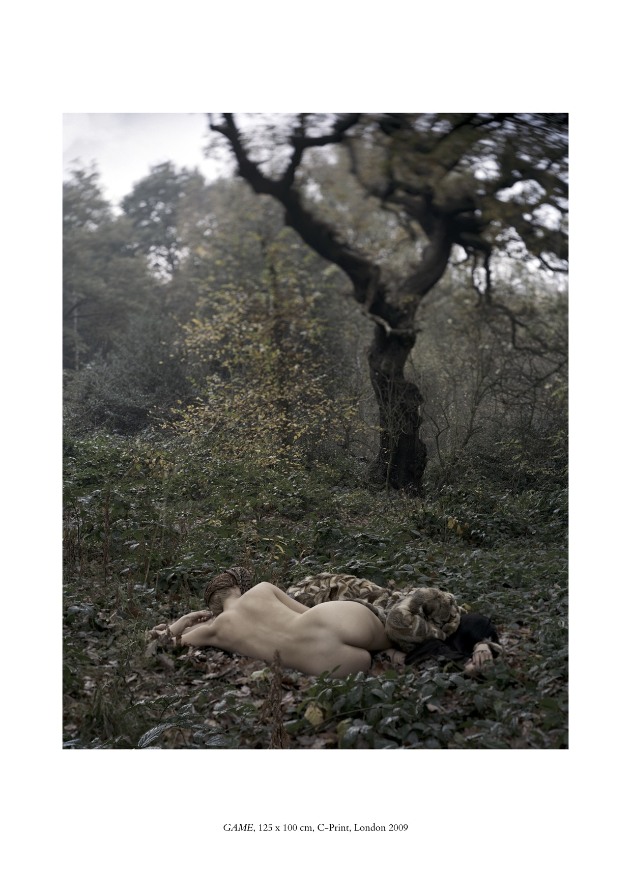

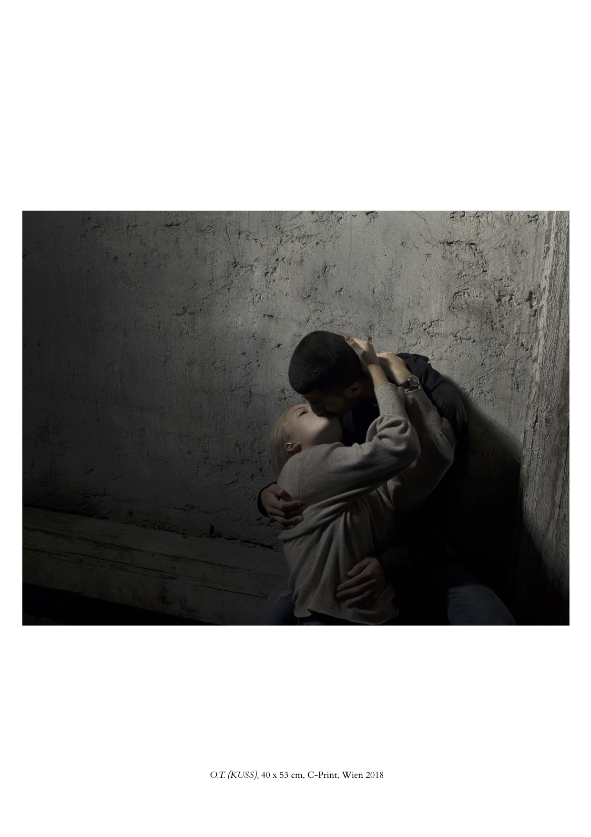

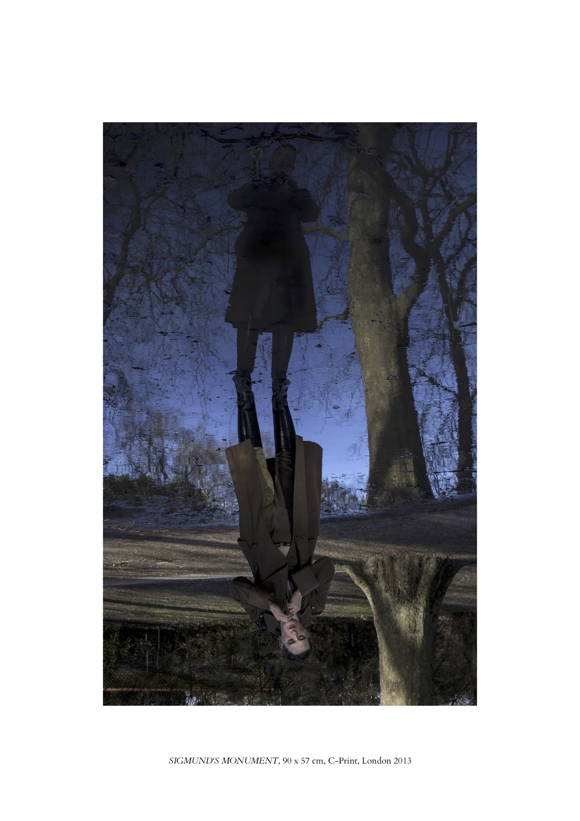

Freud cites Otto Rank’s research into the notion of “the double”, the twin, the effect “of meeting one’s own image unbidden and unexpected”, for instance when encountering an accidental positioning of mirrors or reflections. (**RN: *Kuss***; ***Sigmund’s Monument***)

The double is associated “with shadows, with guardian spirits, with the belief in the soul and with the fear of death”. (**RN: *Game***) Freud writes: “The ‘double’ was originally an insurance against the destruction of the ego, an ‘energetic denial of the power of death’, as Rank says; and probably the ‘immortal’ soul was the first ‘double’ of the body.” The “double”, Freud continues, is “a creation dating back to a very early mental stage, long since surmounted . . .” As a person leaves childhood narcissism behind, “the ‘double’ reverses its aspect. From having been an assurance of immortality, it becomes the uncanny harbinger of death.” (**RN: *Aurelien*; *Nothing Disappears II***) Freud remarks that the “double” becomes the site of a “special agency” slowly forming there, observing, censoring and criticising the self, becoming our “conscience”. His comment allows us *an uncanny* peek into his future: three years later he published his ground-breaking, much developed description of this very mechanism, which he named the *über-ich,* the super-ego.

Freud concurred with the philosopher Friedrich Schelling who said that “everything is *unheimlich* that ought to have remained secret and hidden but has come to light.” Nowak’s photographs somehow achieve this feat. They are not illustrations of what is evident. Rather, they leave us with the impression that she has conjured up something, has had us catch sight of something not only out there but within us, something previously concealed, unconscious, and now inducing feelings of the uncanny.

****

**Note**

Excluding Gertrude’s lines from Shakespeare’s *Hamlet*, all quotations are from Sigmund Freud, *The Uncanny* (1919),Standard Edition, XVII, 217-256, except for the quotation from his *Totem and Taboo* (1913), S. Ed., XIII, 86.

Grateful thanks are owed to curator Anya Dorofeeva for providing the images used here from her 2019 exhibition selection of Rita Nowak’s photographs.

Patricia Morris, is a psychotherapist based in London. She is the author of *Albert Schweitzer: The Difficulty of Doing* Good; *Albert Schweitzer: Cold War Casualty;*

*Love & Sex: 50 therapy lessons;* and *Freud, Politics and Civilisation – an essay.*